* 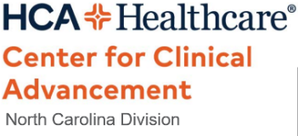**Education for intraop nursing Picklist charting**

**DATE: 12/6/2022**

**HCA Center for Clinical Advancement NC Division**

* **How to update the picklist search preferences**

