

# Meditech Helpful Hints – Care Model: RN/LPN

**Status Board (**\*navigation buttons may be in different order from the below)

Save or F12 Exit or F11

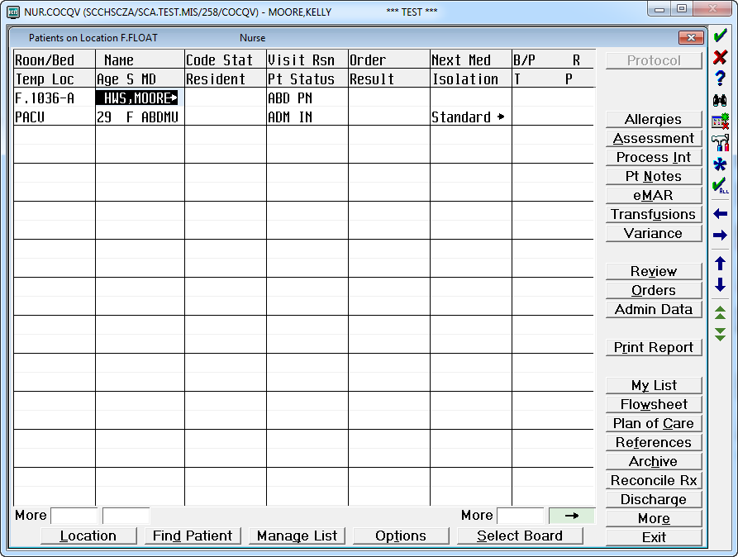

Quick Start Admission/Shift Charting

Patient Notes Medication Administration Blood Administration

View Labs/Reports

Orders

Print Pt Information Kardex’s and SBAR

Home Medications

Set up Patient List

Pt Discharge Process

Lookup or F9

Check Marks or Rt CTRL & Refreshes Status Board

Directional Keys

Page up & down

Plan of Care is in Process Interventions

Name/Mnemonic Searches: N\ + First 3 letters of the Last Name (Dr. Smith = N\SMI) T= Today, N= Now, T-1 – Yesterday, T+1= Tomorrow

Add Intervention (AI)- Ex; BCTA Pre Issue Checklist

Allergy Link (AL)- Opens Allergy routine

Change Directions (CD)- Changes frequency

Change Status (CS)- Changes status A->C

Edit Text (ET)- creates A note below the Intervention

Patient Note (PN)- Opens Pt Notes

Process Meds (PM)- Opens BCMA routine

View History (VH)- Viewing/correcting Documentation

Document Now (DN)- Care just NOW given

Document Intervention (DI)- Documents

care given at any time

**Process Interventions**

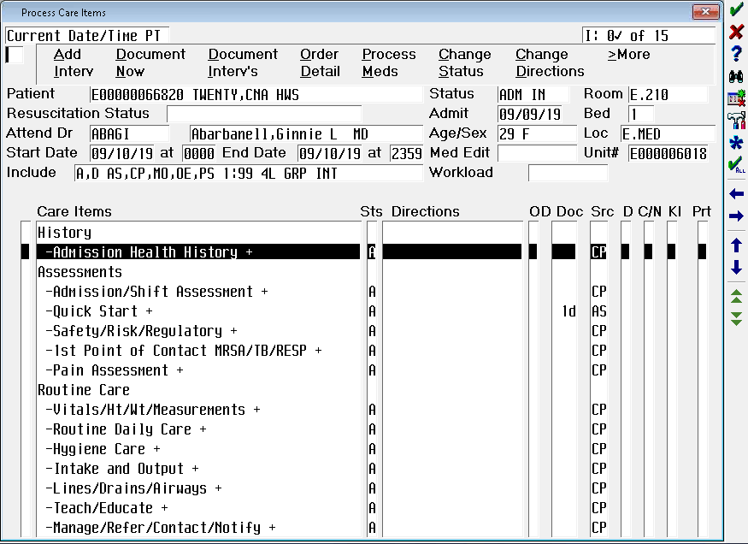

Verb Bar Choices

Documentation interventions

**Meditech Documentation Workflow Huddle Card – Inpatient Nursing**

**This is a general guide for items to be documented.**

**Please refer to your facility and unit specific documentation requirements.**

# 

|  |
| --- |
| **Nurse** |
| **Process Interventions**  Pain Assessment Vitals/Ht/Wt/Measurements Intake and Output Lines/Drains/Airways –  Access Start/Monitoring/Deaccess Teach/Educate Manage/Refer/Contact/Notify  **RN:** First Plan of Care  **LPN:** LPN may not initiate Care Plan but may contribute by updating goals and outcomes  **RN:** Admission Assessment  **RN/LPN:** Shift Reassessment (An RN must complete one of the shift assessments within a 24 day)  **RN:** Must initiate Blood and Blood Products   * BCTA Blood Bank Product * BCTA Pre-Issue Checklist * BCTA Suspected Transfusion Reaction   **LPN:** LPN may not document transfusion reactions    **Patient Notes**  **Orders**  Acknowledge New Orders per unit policies.  **Change of Shift/Handoff**  Review Orders and eMar |
|  |

